Optimizing Power Consumption on Home Appliances using Machine Learning

**Vinay Bansal**

Chief Executive Officer, Faststream Technologies,

Bengaluru, Karnataka, India

[*vinay@* *faststreamtech.com*](mailto:vinay@gmail.com)

**Vinod Agrawal**

Chief Technology Officer, Faststream Technologies,

Bengaluru, Karnataka, India

[*vinod.agrawal@* *faststreamtech.com*](mailto:vinod.agrawal@%20faststreamtech.com)**Sudhanva Narayana**

Machine Learning Engineer, Faststream Technologies,

Bengaluru, Karnataka, India

[*vinod.agrawal@faststreamtech.com*](mailto:vinod.agrawal@faststreamtech.com)

**Shreyas S**

Machine Learning Engineer, Faststream Technologies,

Bengaluru, Karnataka, India

[*hello@shreyas.im*](mailto:hello@shreyas.im)

**Abstract:** Power (electricity) optimization will be a crucial task in the coming years as there will be a limited supply. While we run out of electricity, it will affect both domestic and industrial applications. This paper demonstrates techniques and strategies to optimize power consumption when there is a limited supply, using Machine Learning to predict the amount of electricity consumed at a given hour for a given device specifically for home appliances. It also notifies the user of excess power consumption and also suggests measures to save power. It also considers factors like weather, time of the day and type of the device and the device priority to make the final decision. Machine Learning algorithms such as Multiple Linear Regression, Decision Tree Regression, Random Forest Regression are used to predict the values. We present the result of each algorithm by showing in how much each algorithm is better (or worse) compared to the rest of the algorithms.

**Keywords:** *Machine Learning, Regression, Home Automation, Internet of Things*

**I. INTRODUCTION**

In an indication of growing appetite for electricity and with the increase in usage on electric devices, optimizing it will become a huge task. Machine Learning is a fantastic technique when it comes to predicting values. In this paper, we use multiple regression techniques to predict power consumption based on previously given data. After the values are predicted, a custom algorithm is used to limit power consumption by identifying devices that are consuming more power, by type of weather, by rooms and notify the user of its excess power consumption. It also considers factors like a number of people in the room and time they have stayed in that room. In this way, the total power consumption of devices is reduced per month. However, the power consumption per day is not considered limited. Machine Learning is used only to predict the power consumption at that point in time and not to predict or understand the behaviour of people. As there is no real data, we used a random number generation and time series generator to generate a dataset of certain attributes on which we used to train our models. We later used another generated dataset to predict values from the trained model using regression.

Regression is a set of statistical processes for estimation of the relationship among data points and variables. It predicts the conditional expectation of the dependent variable when given the independent variables, that is the average of both dependent and independent variables. A function of the independent variables is estimated and the values are predicted using probability distribution.

**II. LITERATURE SURVEY**

A lot of work has been put into the field of Machine Learning and in power saving methodologies. Many fields including Internet of Things (IoT) and smart cities are showing great results in terms of power saving.  *Christian Beckel, Heinz Serfas* **[1]** have discussed classification and detailed analysis of requirements that have to be addressed in order to enable application development in smart homes. It also proposed a multi-layer framework on how applications can be developed using multi-layers of abstraction. *Guiqing Zhang, Xianghe Ji, Chengdong Li, Liang Tao, Xiaolong Wu* **[2]** in their paper on energy saving used a custom algorithm that fuses detected electric current information and sensors information to assure that the circuit is cut off when household appliances in that circuit are powered down. *Wellen S. Lima, Eduardo Souto, Thiago Rocha* **[3]** used machine learning techniques to automatically recognize the user's activities and then a ranking algorithm is applied to related activities by giving recommendations to the user whenever it detects a waste of energy. *Manoj Manivannan ID, Behzad Najafi and Fabio Rinaldi* **[4]**tell us about how separating the AC consumption from the consumptions of other residential appliances can help in predicting values. *Vibhatha Abeykoon, Nishadi Kankanamdurage* **[5]**, the purpose of machine learning is to identify the relationship between power consumption characteristics in order to detect electrical devices in real time.

**III. DATASET GENERATION**

As there is no real data, we are using a random number generator and time series generator to generate a dataset. The dataset we generated consists of multiple attributes such as device, room, weather type, date, from time, to time, time of day, a number of people and time stayed. We use the python’s popular numerical computation library ‘numpy’ and data structure ‘pandas’ to generate random numbers for the dataset and time series data. A sample dataset is shown below (**Figure 1)**.

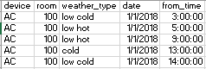

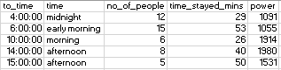

***Figure 1 – Sample Dataset***

Column power is also generated along with it in terms of kilo watt hour.

* Device: All home appliances
* Rooms: (any room number)
* Weather Types: cold, hot – low, medium, very
* Date – one month
* From/To - 1 hr frequency
* Time – morning, afternoon, evening, midnight
* Power consumption – Kilo Watt-hr

7 devices, 6 weather types, 1 month of date range, data of every device for every single date range are generated. Random values are generated for a number of people, time stayed in minutes and weather type, rooms, devices are randomly selected. Time of the day is selected as per the time series. We generated one dataset with power consumption and one without power consumption.

**IV. METHODOLOGIES**

Once the dataset is ready, it is loaded into our program. We use python’s ‘pandas’ library to load in data as a data frame. We visualise the dataset in terms of power consumption across all devices **(Figure 2)**. From the chart, we can see that AC and Heater consume more power than the rest of the devices. We also plot total power consumption every day and power consumption at every hour.

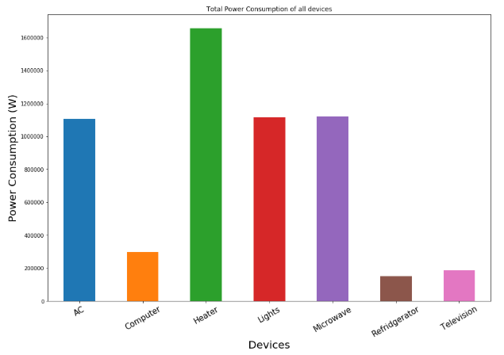

***Figure 2 – Power consumption of all devices***

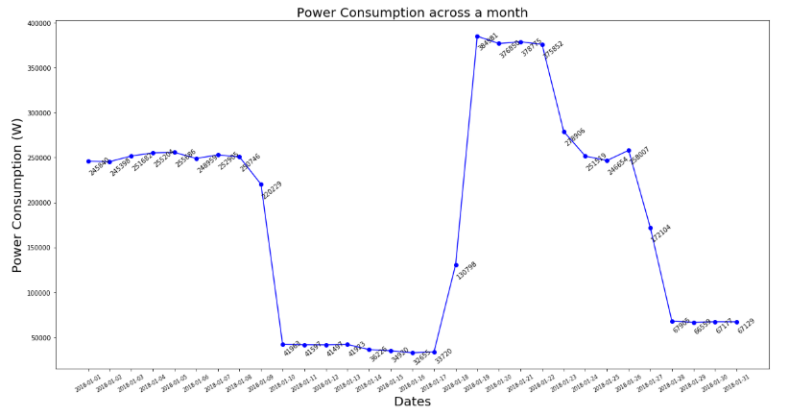

***Figure 3 – Power consumption (daily frequency)***

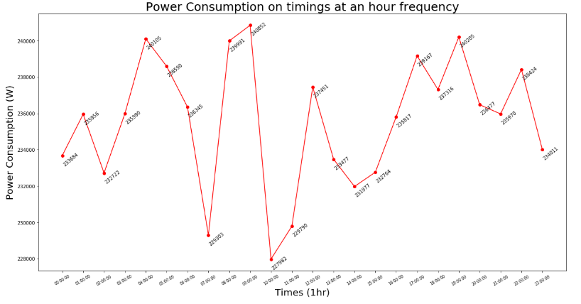

***Figure 4 – Power consumption (hourly frequency)***

A database consisting of maximum power consumption per day and total power consumption per month is created. A sample database is shown in **Figure 5.** This database has a date, time and maximum power consumption limit at that time.

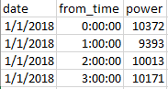

***Figure 5 – Maximum power limit at that hour***

Another database containing devices and their priority in terms of time of the day and the type of weather is created. A sample database is show in **Figure 6**.

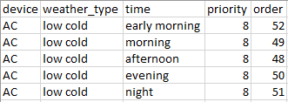

***Figure 6 – Priority database of devices***

***1. PREDICTION***

The next step involves applying machine learning to build our model. The data is split into a training set and test set and is evaluated based on the regression validation metrics. The algorithms specifically used are multiple linear regression, random forest regression and decision tree regression. Since the dataset contains multiple independent features and only one dependent feature, these algorithms are appropriate to be used. The model is trained on these algorithms separately and is saved.

Now, the unseen data is loaded, the saved model is loaded and is used to predict the dependent variable, that is the power consumption values. Below is a sample of the data including the power column, that is predicted by one the algorithms used above.

**2. *CUSTOM ALGORITHM***

Based on the previously created maximum power consumption database, a custom algorithm is used to give out a message and action to be performed. The message and action are given based on the priority database created. A new dataset is created with messages, actions and power saved is appended to the existing database. A sample message looks like this.

*“Moving 10 people from room 119 to room 105 saves 1188.0 of electricity, power consumption will reduce from 10507.0 to 9319.0”.* A sample action looks like this “*Turn off AC in room 119”.*

**V. RESULTS**

We take the mean power consumption per day for that hour versus the mean power consumption that was previously specified and then plots the outcomes. We do this for all the three machine learning algorithms.

**Figure 7** represents multiple linear regression, **Figure 8** represents random forest regression and **Figure 9** represents decision tree regression.

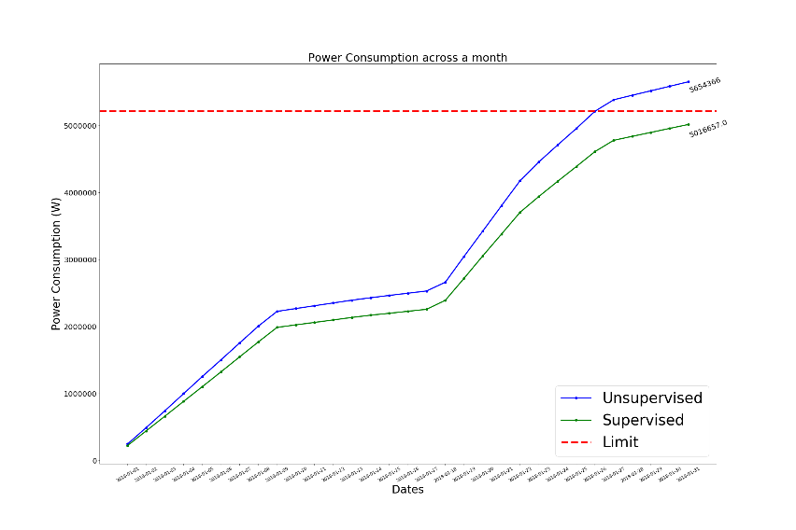

***Figure 7 – Multiple Linear Regression***

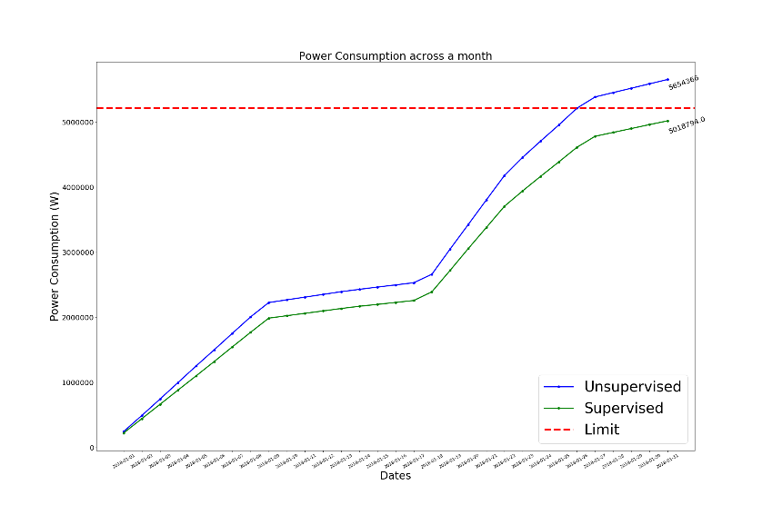

***Figure 8 – Random Forest Regression***

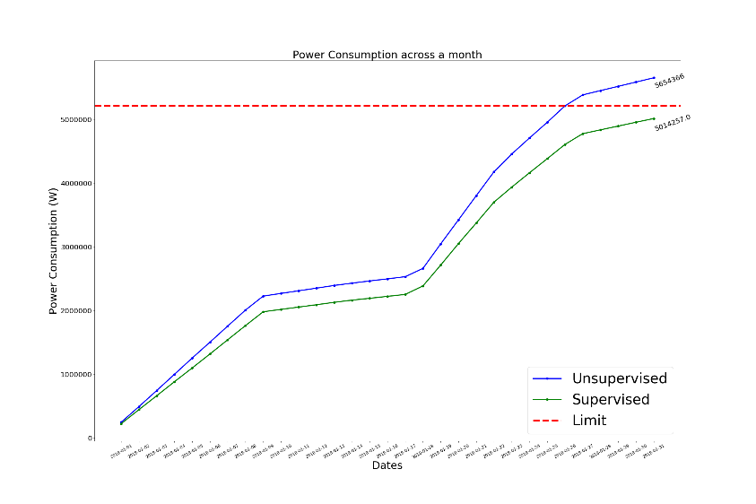

***Figure 9 – Decision Tree Regression***

All machine learning algorithms perform significantly well as shown in the graphs above. The green line represents the power consumption when there is a custom algorithm used. The blue line represents the power consumption when there is no algorithm used. As per the experiment, the green line falls below the red line (limit) hence indicates that it is supervised.

**VI. CONCLUSION**

We conclude that, by using machine learning algorithms, we can predict the future power consumption outputs, take decisions on those outcomes and finally limit power consumption in a given month. Since the dataset we used is simulated, the results shown are only for representational purpose. The machine learning algorithms showed similar results and are proved to be useful. This method can be applied or experimented with real-world data as the simulated data is close to being real. By notifying the users based on priority, we can save power without troubling the average daily user. While this paper is limited to simulated data and home appliances, this methodology can be used to almost any electrical appliances which drive home automation, internet of things and smart cities.

**VII. REFERENCES**

[1] Christian Beckel, Heinz Serfas, *Requirements for Smart Home Applications and Realization with*

*WS4D-PipesBox*

[2] Guiqing Zhang, Xianghe Ji, Chengdong Li, Liang Tao, Xiaolong Wu, *Research on Energy-saving Control of Standby Household Appliances*

[3] Wellen S. Lima, Eduardo Souto, Thiago Rocha, *User Activity Recognition for Energy Saving in*

*Smart Home Environment*

[4] Manoj Manivannan ID, Behzad Najafi and Fabio Rinaldi, *Machine Learning-Based Short-Term Prediction of Air-Conditioning Load through Smart*

*Meter Analytics*

[5] Vibhatha Abeykoon, Nishadi Kankanamdurage, *Electrical Devices Identification through Power Consumption using Machine Learning Techniques*